**MINI PROJECT REPORT MID SEMESTER**

**WEB FRAMEWORK PROGRAMMING**



**Arranged by :**

**Luqman Naufal Lufthansa 3.37.18.0.10**

**Muhammad Andriyan Fikri N. 3.37.38.0.12**

**Muhammad Faza Hanif 3.37.18.0.14**

**IK - 2C**

**INFORMATICS ENGINEERING STUDY PROGRAM**

**ELECTRICAL ENGINEERING MAJOR**

**STATE POLYTECHNIC SEMARANG**

**2020**

1. **PURPOSE**

The purpose of making this Batik Store Website are:

1. Help the Batik Store Malioboro in Yogyakarta City to sell the various batik product for the whole of Indonesia or even overseas.
2. Facilitate for the buyer to buy batik if it is far away, to buy it through the website.
3. **BASIC THEORY**
4. **E-commerce**

E-commerce is a part of e-business, where the scope of e-business is broader, not just commerce but also includes collaborating business partners, customer service, job vacancies, etc. In addition to the www network technology, ecommerce also requires database or database technology, e-mail, and other forms of non-computer technology such as goods delivery systems and payment tools for this e-commerce.

1. **Framework**

A framework is a set of conceptual structures and guidelines, which are used to build something useful. So to say the framework is software to make it easier for programmers to create a web application.

In a software framework, a Software Framework is a structure that you can use to build things. The Software Framework allows you to use different types of components, communicate with external APIs and determine the structure of the application.

1. **Laravel**

Laravel is a PHP framework released under the MIT license, built with the concept of MVC (model view controller). Laravel is an MVC-based website development written in PHP that is designed to improve software quality by reducing initial development costs and maintenance costs, and to improve the experience of working with applications by providing expressive, clear and time-saving syntax.

MVC is a software approach that separates application logic from presentation. MVC separates applications based on application components, such as: data manipulation, controller, and user interface.

By using the MVC structure, it makes laravel easy to learn and accelerates the process of making web application prototypes. This framework also provides built-in features such as authentication, mail, routing, sessions, and the list goes on.

1. **PhpMyAdmin**

PhpMyAdmin is a free PHP scripting language based software that aims to make it easier for us to manage MySQL databases. Without phpMyAdmin, you need to use a terminal to manage your database. Meanwhile, with phpMyAdmin you no longer need to manage your MySQL database because phpMyAdmin has a graphical user interface.

PhpMyAdmin supports many MySQL, MariaDB, and Drizzle operations so you can use it to manage databases, columns, tables, indexes, users, and much more. At the same time, you can also execute any SQL statement directly.

1. **Website Overview**

This project is an online computer shop that uses Laravel as its framework and includes two views, namely for admin and customers, for admin views it includes adding, editing, and deleting products and also viewing customer product purchase tables, for customer views including product lists, details customers until checkout

1. **TOOLS AND MATERIALS**
2. Laptop or PC
3. Text Editor (Visual Studio Code or Sublime Text)
4. XAMPP (Web Server/PHP/MySQL)
5. Browser (Chrome, Firefox, Edge/IE)
6. **WORK STEPS**

Shop features:

* Can add multiple accounts
* Can log in according to each account
* Can add items to the basket
* Can see product details
* Can shop until Checkout

1. This is the first page of this web. There is two choices at the corner, login and register.

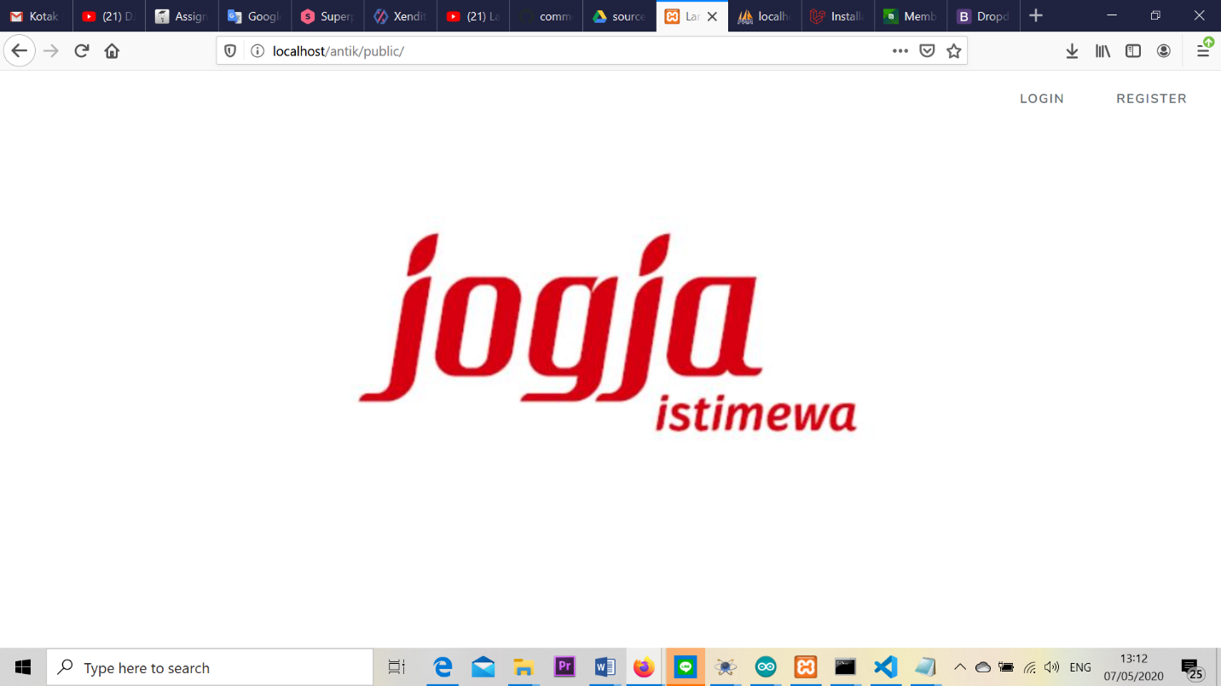

If we don't have an account, we must first create an account on this register page.

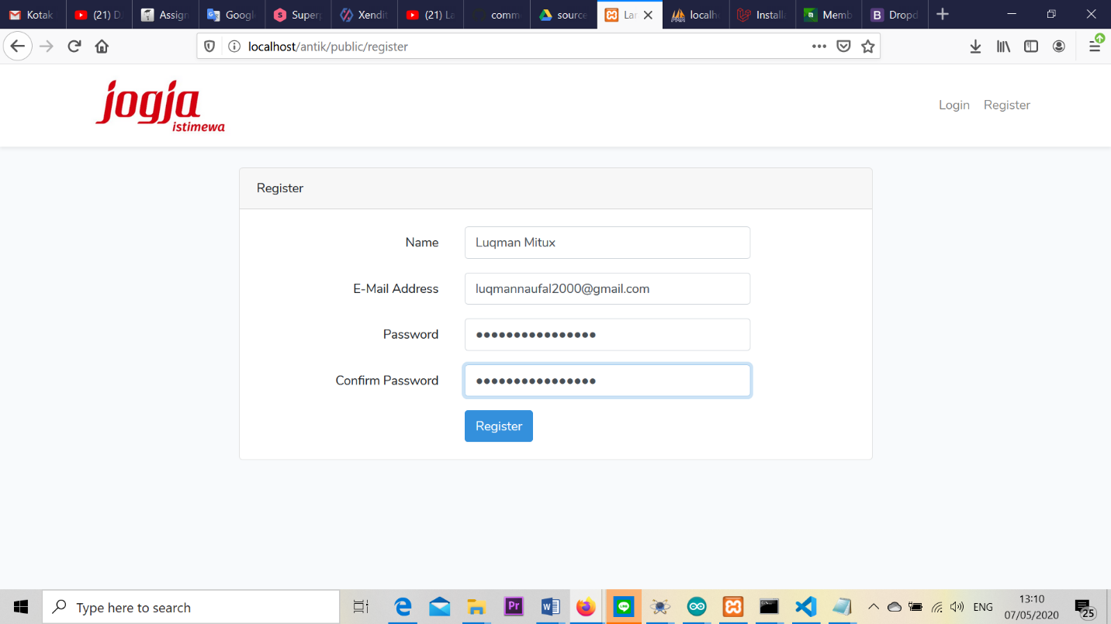

And if we already have an account, then we can directly log in on this login page.

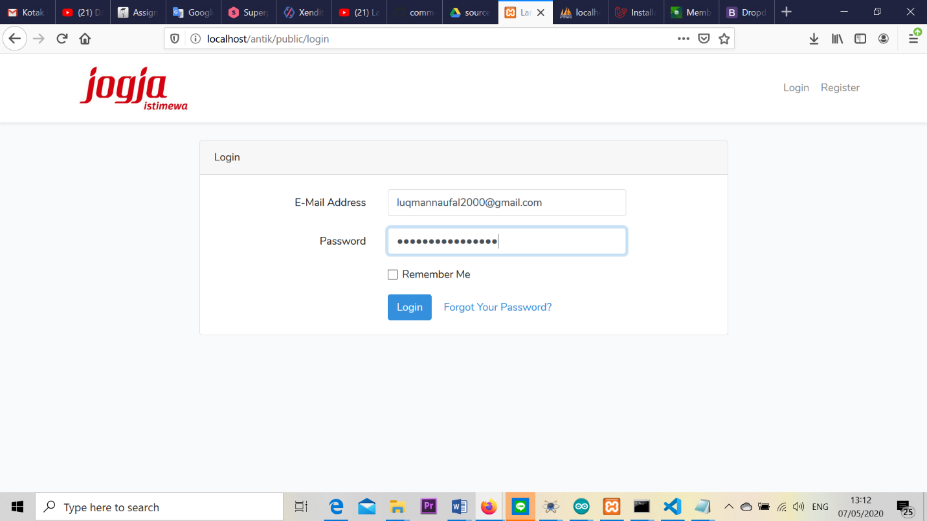

1. When we already log in with our account, we will see this main display from this web. This page show the products we will sell it.

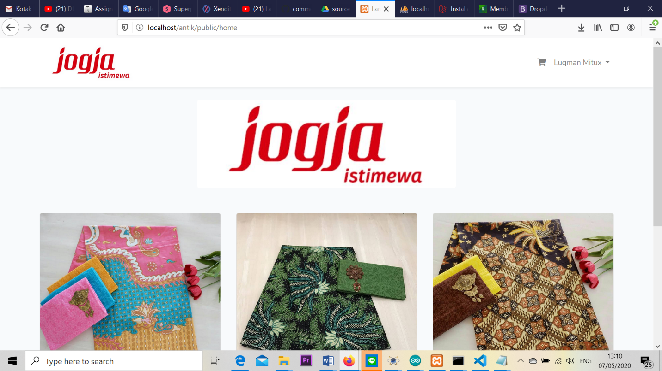

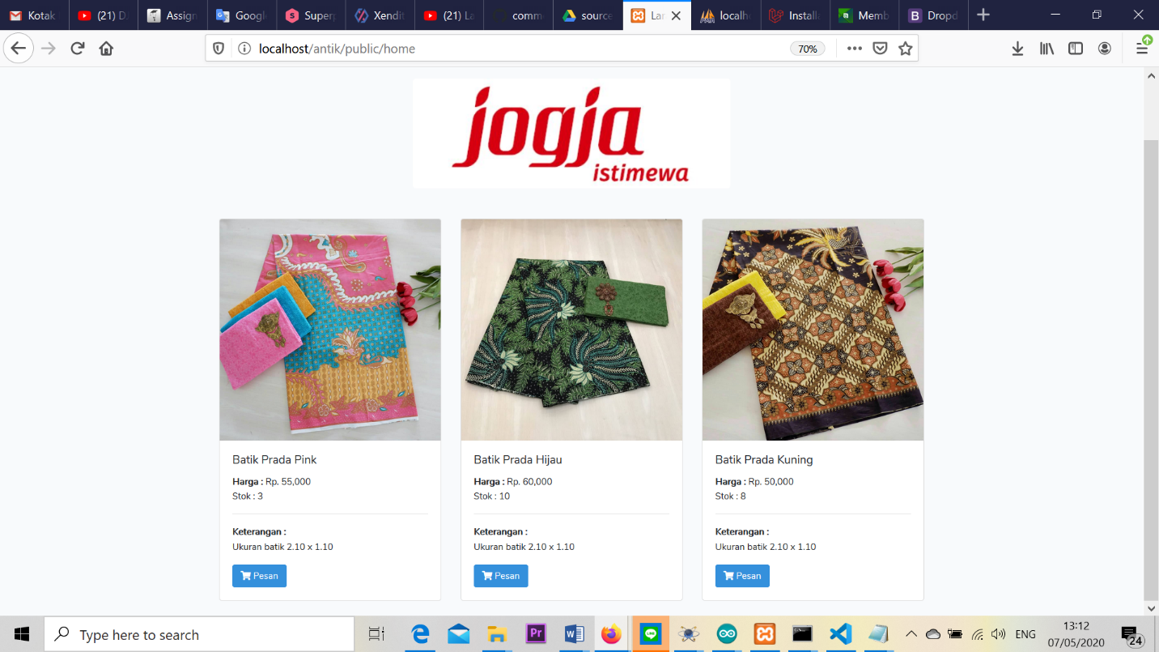

1. Then if we want to buy the product, we can click at the product what we want to buy. So, the display will show the information of the product.

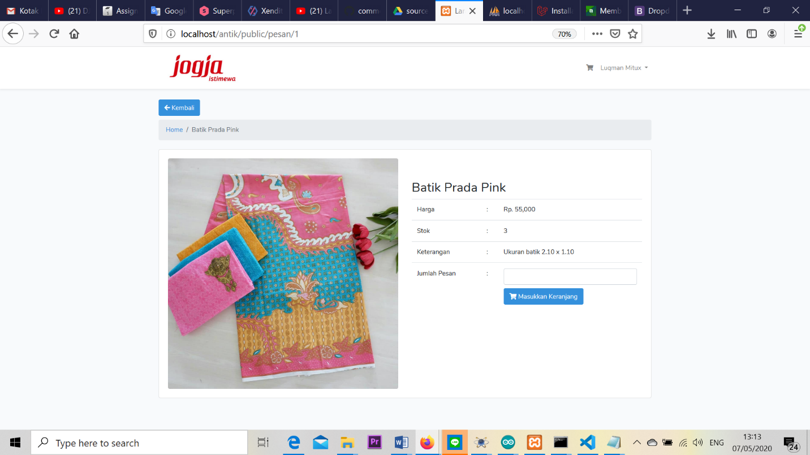

1. After we decide what product we will buy, if we want to checkout the product just click at the “Masukkan Keranjang” button. So, this is the page of checkout

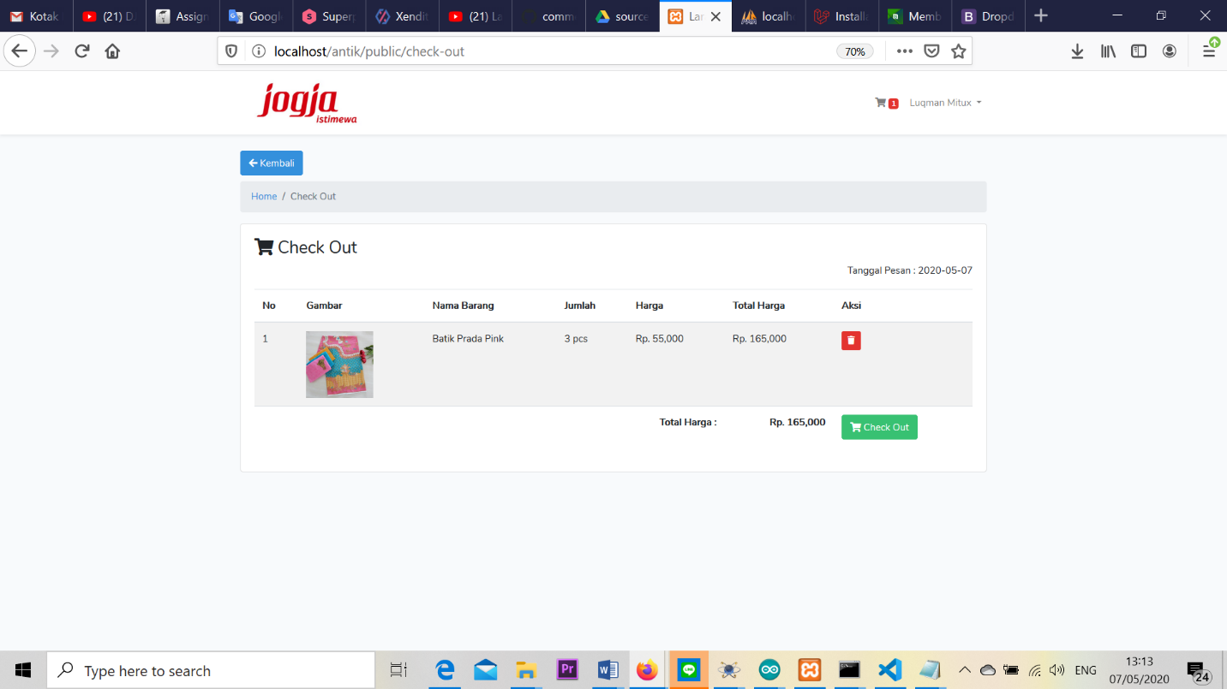

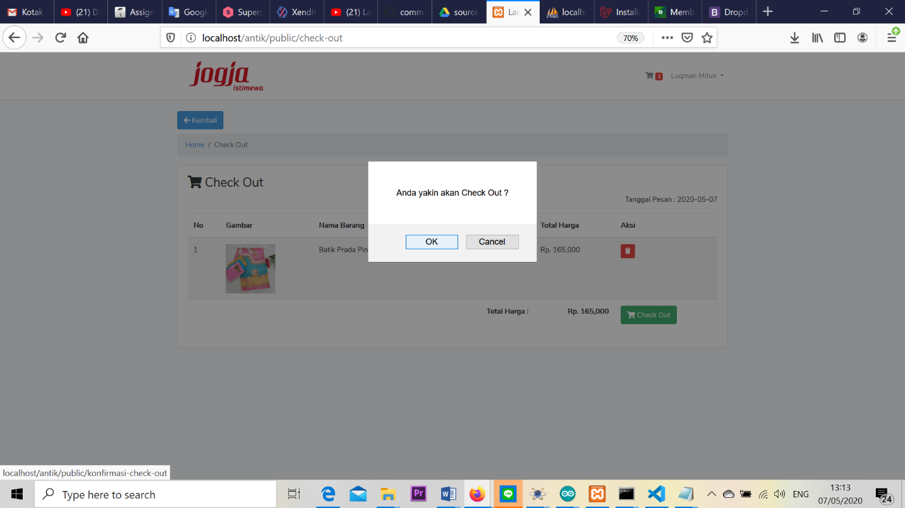

1. Then the last is edit profile page. This page is just for change and update our personal account information. This page contain username, email, telephone number, and address.

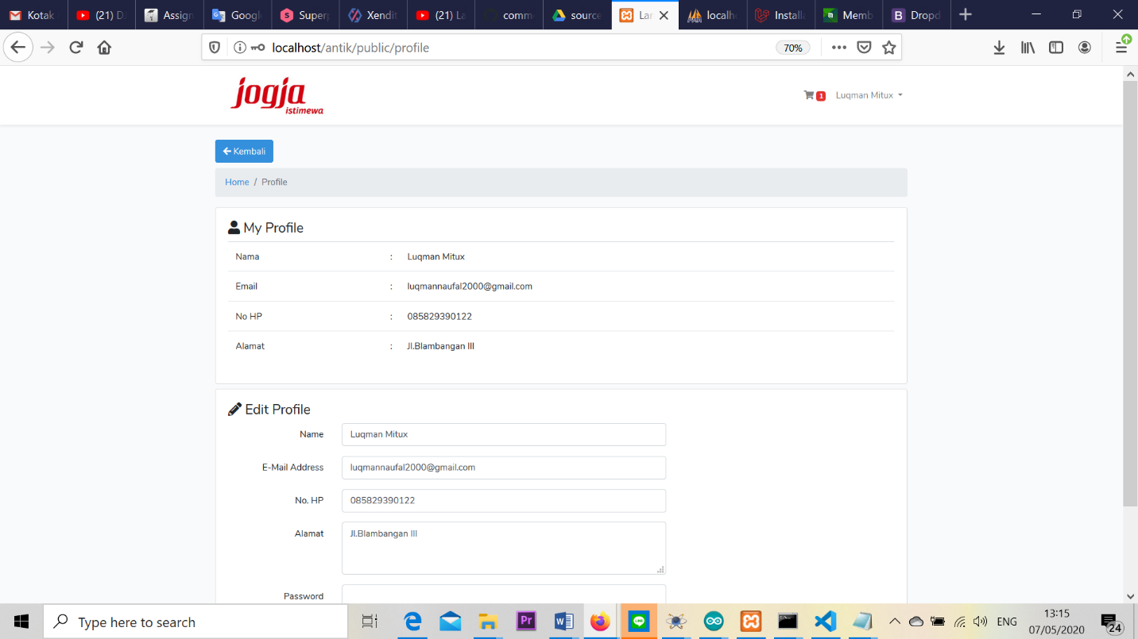

1. **CONCLUSION**

The purpose of this project is for help people to buy the batik product if it is far away, promote the local product for the whole of Indonesia or overseas, and of course to train our skill and knowledge in web development using Laravel. This project is built with Laravel, PHP, MySQL and use the MVC and CRUD.